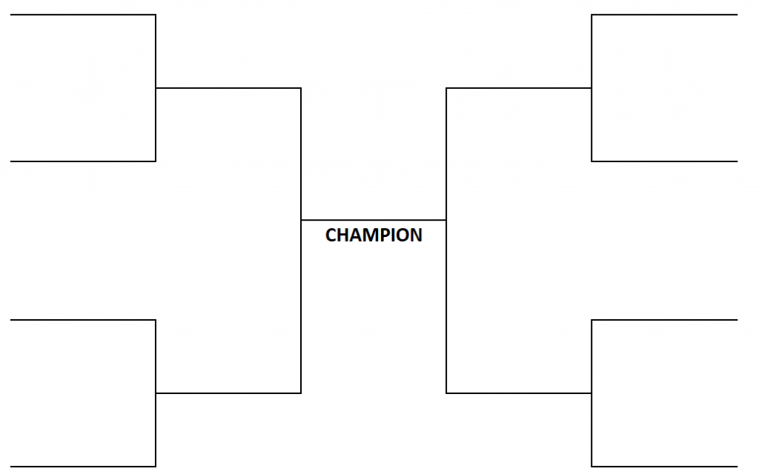

Hope is a Thing with Feathers

If I Can Stop One Heart from Breaking

32 points

16 points

16 points

16 points

16 points

That Justice Is a Blind Goddess

We Real Cool

l(a

Nothing Gold Can Stay

Dreams

Truth

Name ______________________________________________ Period ____________